Modifying CWMS Model for ESP Analysis
Ross Wickham
Written for CWMS 3.1

Summary
This report documents the process used to modify a ResSim model for use with the Ensemble Streamflow Prediction (ESP) dataset developed by the Northwest River Forecast Center (NWRFC). The modification will allow Monte Carlo analyses to be quickly computed in forecast scenarios, providing a statistical likelihood for conditions of concern in the watershed. The major effort of modification involves remapping ESP inflows to CCP flow locations used in the ResSim model (Inflow Modifications section). Section layouts in this document are as follows:
Deployment – how to take the CAVI model from the initial CWMS development and modify for use with ESP data
Inflow Modifications – background on some of the required relationships used to establish ESP feeds at locations without ESP data
ESP Flow Modification – background on how the ESP flow modification tool works and its inputs
Running ESP Simulation – how to run an ESP simulation once initial setup of CAVI for ESP is completed

Deployment
The following sections outline the steps, in sequence, needed to develop a CWMS ESP watershed from a CWMS watershed

Initial Tool Setup

Download ‘cwms_esp’ from GitHub
The cwms_esp tool is on GitHub at the following url:
https://github.com/RossWickham/cwms_esp
Download the tool as a zip file:
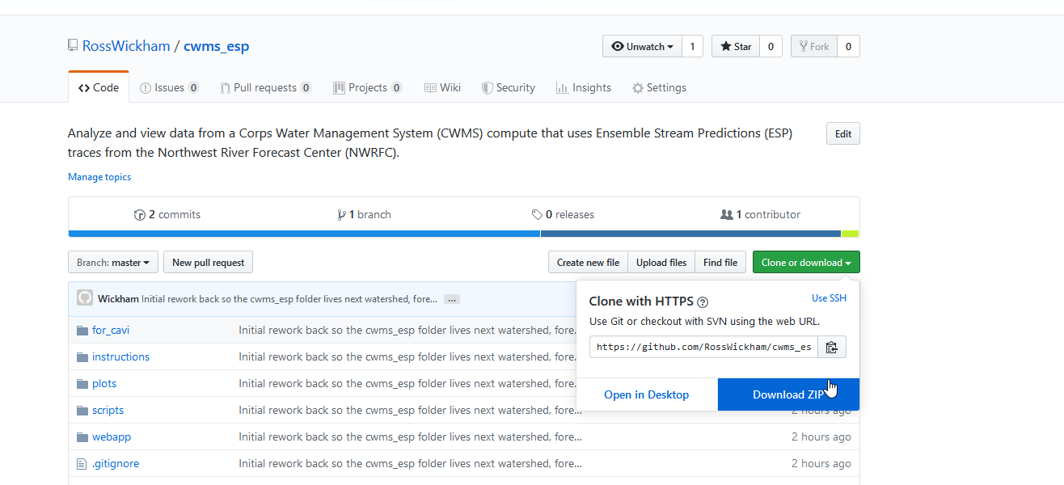
Unzip into the main CWMS directory containing the watershed, forecast, and database folders:
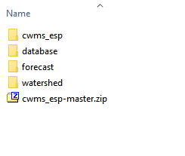
Alternatively, you can download the tool using the Git application if you’re familiar with it.

Configure R and Java
In order to run these scripts, you will need R (with necessary packages installed) and 64-bit Java. Talk to NWW personnel (Ross Wickham or Jon Roberts) if you need copies of R and/or Java. Within the cwms_esp tool’s main directory, there is an ‘r_java_config.bat’ file that contains the information needed to configure the executable locations of R and Java.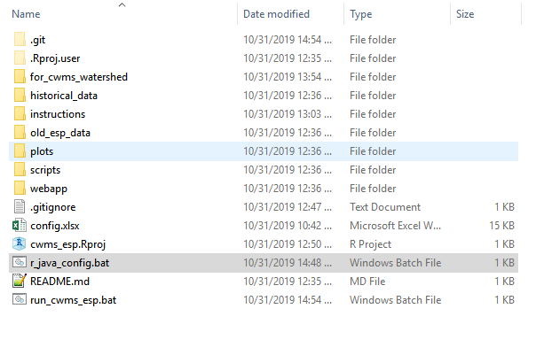’
Right click the file and click ‘Edit’. The lines beginning with ‘set’ establish the ‘rExecutablePath’ and ‘baseJavaDir’ variables. Point these to the fully qualified paths for the Rscript.exe and base Java directories as shown below. Lines that begin with ‘rem’ are comment lines (remarks). Note that some set lines are commented out from R installations used during testing:
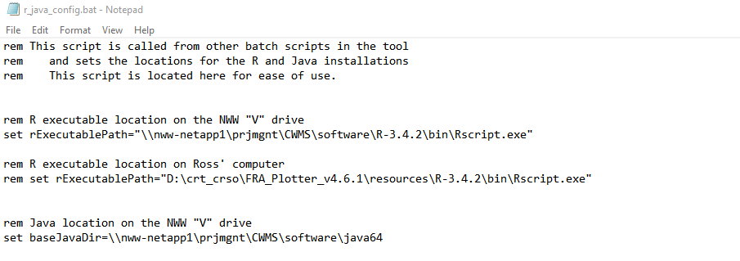
This script is called by the ‘run_cwms_esp.bat’ script and the ‘Download_ESP.bat’ that is copied into the watershed’s ‘scripts/esp_download’ folder. It is advantageous to point to R and Java installations on a server that can be reached by other computers in the office to make the tool more portable.

Copy Scripts and Configurations into CWMS Watershed
Copy the ‘scripts’ and ‘shared’ folders from “../cwms_esp/for_cwms_watershed” folder into your CWMS watershed’s base directory:
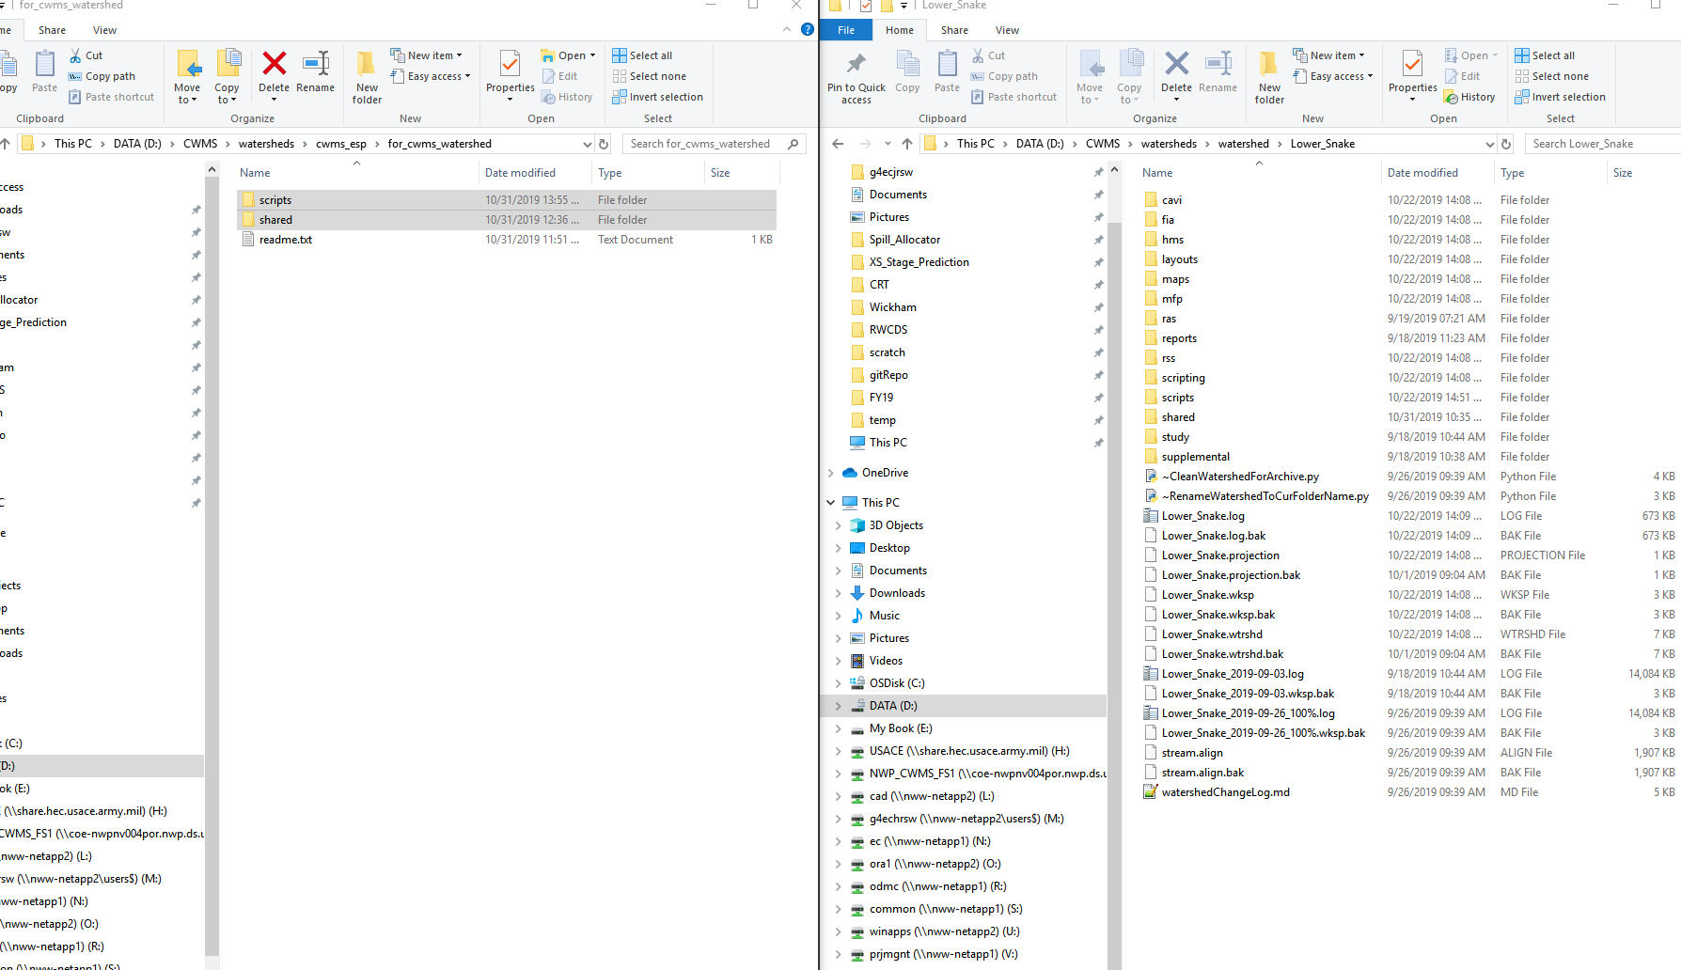

Your base CWMS directory should now have the following folder configuration:

ESP Download Setup
ESP traces are downloaded via the ‘scripts/Download_ESP.py’ script that is added to the CAVI scripts tab. It can also be run manually via the ‘scripts/esp_download/Download_ESP.bat’ file. The script retrieves the RFC site IDs as defined in the ‘cwms_esp/config.xlsx’ ‘download_sites’ tab. Note: the script matches the entered NWRFC IDs against those in the ‘scripts/esp_download/rfc_esp_links.xlsxm’ Excel file’s ‘csvFileName’ column in the ‘natural’ tab using regular expressions. Instructions for finding the NWRFC IDs is shown below:

ResSim Setup

Create New ResSim Alternative with ESP Inflows

Ensemble mode, monte carlo tab

Map inflows

Setup Dummy Import Module Rule Script
Set as release rule script of the reservoir that occurs first in the alphabet.
Alternatively, you can put the ‘sqlitejdbc-0.5.4.jar’ file into the CAVI installation’s jar folder (..\CWMS-vx.x.x\CAVI\jar). However, putting the jar file in the CWMS watershed, makes the watershed more portable and will have one less dependency when someone else attempts to run an ESP simulation.

Inflow Modifications

Running ESP Simulation

ESP Flow Modification
This section describes how the flow modifier script derives the local flows used in the ESP simulations.

Three files are necessary to the run the flow modification script, all of which should be located in the …/shared/flow_modifier directory in the watershed.

Configuration Development
This section documents how the tables and configuration files were created.

ModPuls Tables, DSS File

Local Flow Computation, CSV File

Appendix A: Example Linear Regression Fitting of Inflows to CCPs Without ESP Data for Lower Snake Watershed
The inflows at the Tucannon, Lapwai, and Asotin CCPs in the Lower Snake CWMS watershed do not have corresponding ESP data from the RFC. To maintain a non-zero flow at these inflow locations, relationships were created between these locations and other nearby local inflows that do have RFC data. A brute force method was applied to fit single linear regression to each reasonable pairing of RFC forecast location. The following USGS stations were considered for independent variables in the regression fitting:
13351000 Palouse River at Hooper, WA
13341570 Potlatch below Little Potlatch Creek near Spalding, ID
13340000 Clearwater River at Orofino, ID
13317000 Salmon River at Whitebird
13292000 Imnaha River at Imnaha, OR
13342500 Clearwater River at Spalding, ID
13334300 Snake River at Anatone
Dependent variable data were:
13342450 Lapwai Creek near Lapwai, ID
13344500 Tucannon River near Starbuck, WA
13335050 Asotin Creek at Asotin, WA
USGS data were downloaded for the daily period of record at each site. Simple linear regression models were fit to each pairing of independent and dependent model, and the R² and root mean square error were tallied. Although the relationships do show a large amount of scatter, the flows of the Tucannon and Lapwai rivers are small with respect to the Clearwater and Snake Rivers. Thus, the risk associated with under-predicting the flows is small, and the scatter in the linear regression relationships is deemed acceptable. Results of the analysis are provided below, with selected linear regression fits highlighted.
Table 1. Results of linear regression fitting
Independent Variable (x) | Dependent Variable (y) | R² | Coefficient | RMSE (cfs)
palouse | lapwai | 0.69 | 0.11 | 95.02
potlatch | lapwai | 0.75 | 0.14 | 89.72
orofino | lapwai | 0.30 | 0.01 | 139.44
salmon | lapwai | 0.15 | 0.00 | 154.17
imnaha | lapwai | 0.30 | 0.12 | 136.26
spalding | lapwai | 0.39 | 0.01 | 131.72
anatone | lapwai | 0.36 | 0.00 | 132.96
palouse | tucannon | 0.68 | 0.15 | 139.82
potlatch | tucannon | 0.54 | 0.17 | 158.87
orofino | tucannon | 0.60 | 0.01 | 155.16
salmon | tucannon | 0.44 | 0.01 | 184.44
imnaha | tucannon | 0.56 | 0.23 | 164.62
spalding | tucannon | 0.69 | 0.01 | 136.32
anatone | tucannon | 0.67 | 0.00 | 140.85
palouse | asotin | 0.60 | 0.09 | 97.54
potlatch | asotin | 0.50 | 0.10 | 98.22
orofino | asotin | 0.60 | 0.01 | 98.05
salmon | asotin | 0.45 | 0.01 | 114.54
imnaha | asotin | 0.66 | 0.16 | 92.21
spalding | asotin | 0.64 | 0.01 | 92.37
anatone | asotin | 0.65 | 0.00 | 91.05

Tucannon
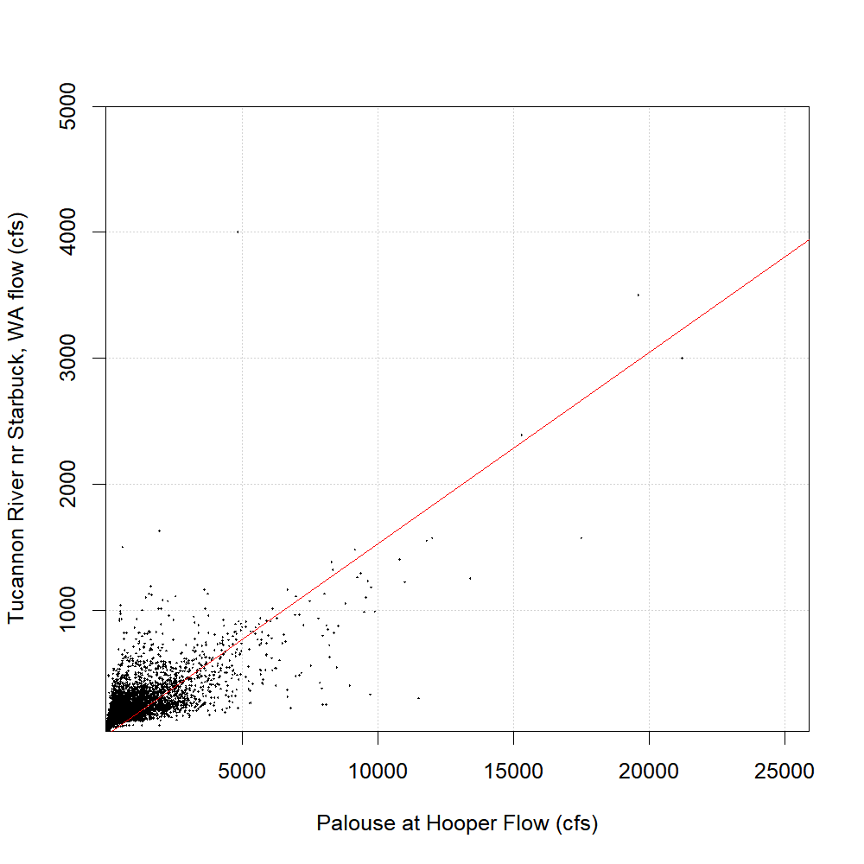
Selected Independent Variable: Palouse River at Hooper, WA (13351000)
Max Recorded Tucannon Flow = 5000 cfs
R² = 0.68
RMSE = 90 cfs
Eqn: Tucannon = 0.15*Palouse
Row in ‘flow_eqn_config_lsr_fullrouting.csv’ file:

Lapwai
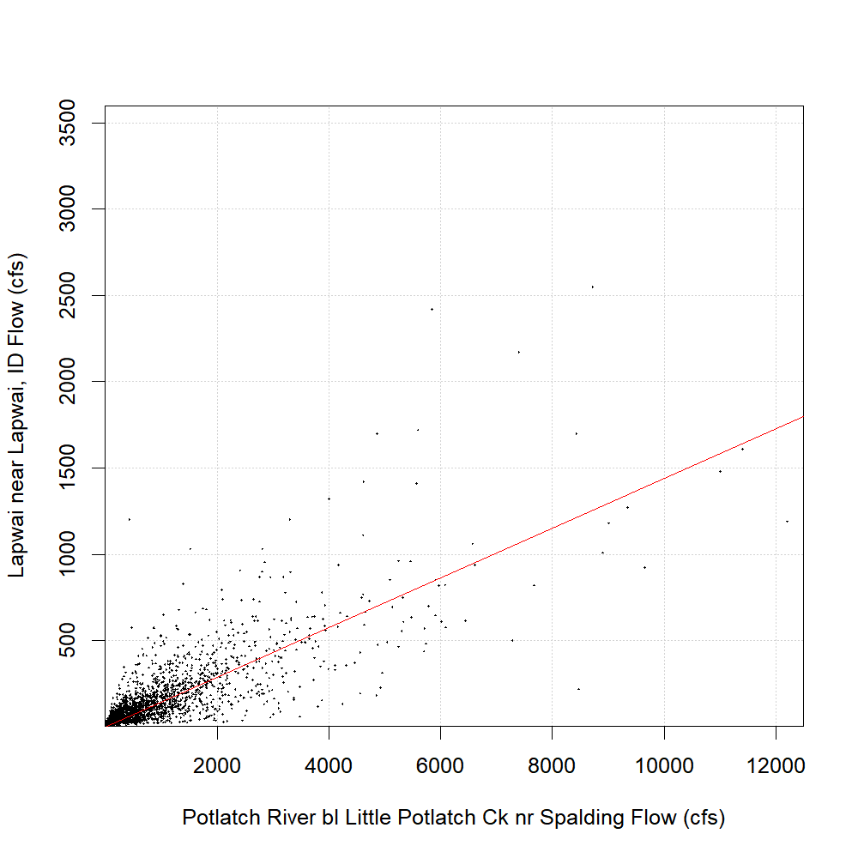
Selected Independent Variable = Potlatch below Little Potlatch Creek near Spalding, ID (13341570)
Max Recorded Lapwai Flow = 3600 cfs
R² = 0.75
RMSE = 140 cfs
Eqn: Lapwai = 0.14*Potlatch
Row in ‘flow_eqn_config_lsr_fullrouting.csv’ file:

Asotin
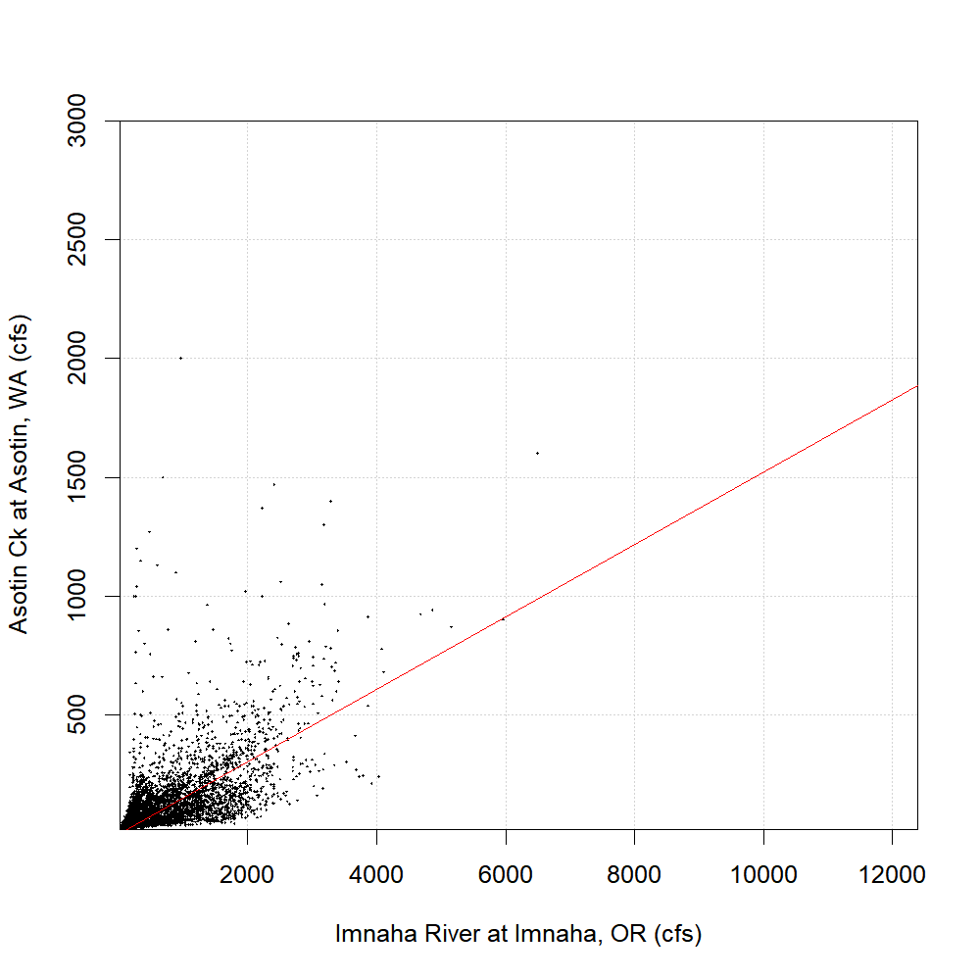
Selected Independent Variable = Imnaha River at Imnaha, OR
Max Recorded Lapwai Flow = 3000 cfs
R² = 0.66
RMSE = 92 cfs
Eqn: Asotin = 0.16*Imnaha
Row in ‘flow_eqn_config_lsr_fullrouting.csv’ file:

